Model EST803 ESD Generator
ESD Simulator, ESD Gun Per IEC61000-4-2
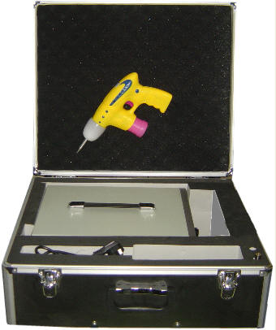
Features
- Contact & air Discharge Output voltage 0.1~±30KV
- High accuracy (1%), High stability (0.5%) and High resolution (10V)
- Polarity and discharge output
- Preset 10 standard test levels enabling the user to quickly select the voltage from the standard test levels
- Pulse discharge waveform conformed to the IEC61000-4-2 standard
- Most light weight gun (500g) makes the test easy and comfortable ergonomics and avoid fatigue in the test
- Safety and reliability design makes it easy to use in many standards
- Used as a high voltage power source with precision (0.5%) regulated positive (0~+30kV) and negative (0~ -30kV) output of 1mA current output.
Selected discharge pulse single discharge, 1P/s, 20P/s and adjustable repeat rate from 1 to 10 seconds.
Specifications
- Output voltage: 0.1~±30KV both air and contact discharge;
- Voltage indication accuracy: ±1%rd+2dig;
- Polarity of the output voltage: Positive and negative;
- Holding time: more than 5s;
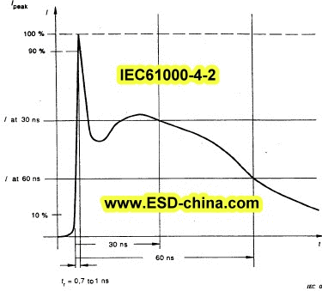
- Charging Resistor Rc between 50M-100M;
- Energy-storage capacitor (Cs+Cd): 150pF±10%;
- Discharge resistor Rd: 330±10%;
- Discharge, mode of operation: single discharge, 1P/s, 20P/s and adjustable repeat rate at 1~10 P/s;
- Output voltage indicator:4 1/2 LED with resolution 10V;
- Waveshape of the discharge current: IEC61000-4-2;
- Power supply: 85V AC ~265V AC /40 Hz ~60Hz;
- Weight: pistol<500g and power source :< 4kg.
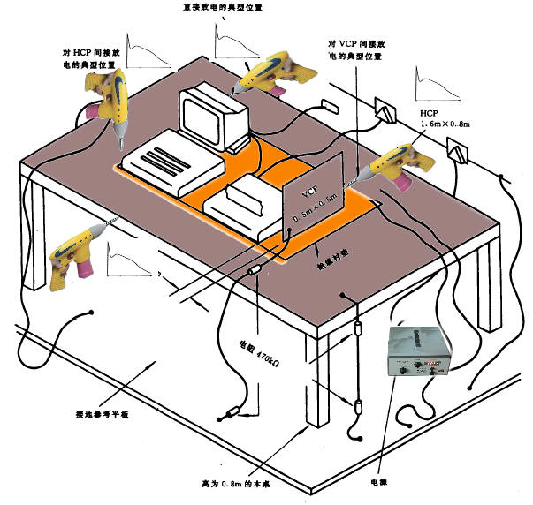
Background
Electrostatic discharge (ESD) immunity test is one of the most important tests in the electromagnetic compatibility (EMC) tests. The International Electrical Committee (IEC) published IEC61000-4-2 (Chinese national standard GB17626.2) for ESD test of the electronic system testing.
The Model EST803 ESD Generator (ESD Simulator or ESD gun) can be continuous adjusted electrostatic discharge pulses voltage from 0.1 to ±30KV in both air and contact discharge operations and exceeding industry ESD test standards requiring pulse voltages of 8kv (contact)/15 kV (air).
Basic model is supplied with 150 pF/330 ohm network in compliance with IEC/EN 61000-4-2, IEC 1000-4-2 and IEC 801-2 / 1991, and other optional extra discharge networks is available The EST803 consists of an adjustable high voltage control unit and a hand-held pulse discharge gun (less than 500g, the world most Light weight gun) connected by a 4-ft cable.
The control unit houses the low voltage power supply and both very precision (0.5%) positive and negative adjustable high voltage (0～±30kV/1mA) power supply with high voltage LED display. It can be used as a precision (0.5%) positive (0~30kV) and negative (0~-30kV) and high resolution (10V) regulated high voltage power with the ability of 1mA current output.
Contact & air discharge voltage ranges from 0.1 to±30kV, 4 1/2-digit LED readout, 10-volt resolution. Preset 10 standard discharge voltage levels enable the user to quickly select the voltage from the standard test levels as the IEC 61000-4-2 standard and air and contact discharge mode.
It is the most Light weight gun (<500g), It is comfortable ergonomics designed. Basic RC network is 330 ohm/150pf (HBM) (IEC61000-4-2) and Optional Custom RC networks available. EST803 can be applied to a wide range of test standards. Test in accordance with IEC, European, North American and China ESD/EMC simulation /Generation standards
Basic Setup
Power source: High voltage (0.1~±30kV) and controller
ESD gun: Interchangeable tip: Air discharge and contact discharge
Power cable
Suitcase
Instrumental manual
All these ESD802, support & service and the low purchase price are some of the reasons experienced test technicians and engineers applaud the EST802 as the best ESD Generator/simulator
http://www.ESD-china.com ESD@ESD-china.com
Tech Consulting: (+86 133)6607.9273 Fax:(+86 10)6352.8264

